**Project Design Phase**

**Solution Architecture**

|  |  |
| --- | --- |
| Date | 17 July 2025 |
| Team ID | LTVIP2025TMID39501 |
| Project Name | GrainPalette - A Deep Learning Odyssey In Rice Type Classification Through Transfer Learning |
| Maximum Marks | 4 Marks |

### Solution Architecture:

Solution architecture is critical in turning complex data-driven challenges into implementable AI-powered solutions. For GrainPalette, the goal is to classify different types of rice grains using advanced deep learning techniques, particularly Transfer Learning. The architecture connects domain-specific needs (agriculture and grain quality control) with state-of-the-art computer vision technology.

* The architecture aims to:
* Identify the best deep learning model to classify rice types accurately with limited training data.
* Leverage pre-trained neural networks (e.g., VGG16, ResNet50, or MobileNet) using Transfer Learning to enhance performance.
* Describe components such as the data pipeline, image preprocessing, feature extraction, classification layers, and evaluation metrics.
* Define key stages of development — data acquisition, preprocessing, training, validation, and deployment.
* Ensure scalability and robustness, enabling adaptation to other grain classification tasks with minimal changes.

### Example - GrainPalette Architecture Diagram:

Figure 1: Architecture and data flow of the GrainPalette system, illustrating the stages of image input, preprocessing, transfer learning-based model processing, classification output, and evaluation.

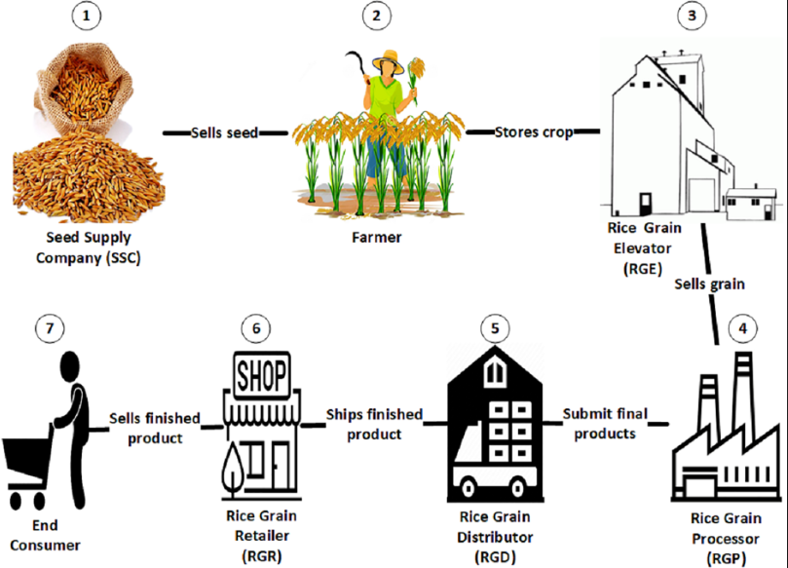

### Reference:

Based on standard deep learning workflows using TensorFlow/Keras Transfer Learning techniques